DESIGN OF A LINE FOLLOWING ROBOT

DEPARTMENT: Mechatronics Engineering

COURSE TITLE: Robotics & Embedded System (ICT 215)

GROUP 8
2024/13193
ABUDU ABDULLAHI EYITOPE
2024/13205
OMEZI CHIZITEREM MAXIMALCOLVET
2024/13206
OSAZEMWINDE ADESUWA SUCCESS
2024/13215
ADEKUNBI ABDUL-RAHMAN AKANBI
2024/13219
OHIEMU TOBIAS AROME

ABSTRACT
The project deals with the design of a line following robot. Our main objective is to develop a system that can track a black line on a white surface. The system contains some key components like IR sensors for detection, a microcontroller (Arduino uno) and motor drivers then a PROTEUS and TINKERCAD was implemented along with a PCB design using proteus. Results from the testing demonstrated that the robot could accurately track path with little deviation. The project report includes a public GitHub repository documenting the hardware schematics, PCB design and Arduino code used in the circuit design.

TABLE OF CONTENTS
ABSTRACT 2
CHAPTER 1: INTRODUCTION 5
1.1 BACKGROUND OF THE LINE FOLLOWING ROBOT 5
1.2 PROBLEM STATEMENT 5
1.3 OBJECTIVE 5
1.4 SIGNIFICANCE 6
1.5 SCOPE AND LIMITATION 6
CHAPTER 2: LITERATURE REVIEW 7
2.1 INTRODUCTION 7
2.2 REVIEW OF EXISTING SIMILAR ROBOT 7
2.3 MICROCONTROLLER SELECTION AND JUSTIFICATION 7
2.4 USE OF PROTEUS AND TINKERCAD 8
CHAPTER 3: METHODOLOGY 9
3.1 SYSTEM BLOCK DIAGRAM 9
3.2 HARDWARE DESIGN 10
3.2.1 ANALOG CIRCUIT DESIGN 10
3.2.2 MICROCONTROLLER PIN MAPPING 11
3.2.3 COMPLETE SCHEMATIC IN PROTEUS 11
3.2.4 SIMULATION RESULTS IN PROTEUS 12
3.2.5 TINKERCAD 3D SIMULATION 12
3.3 PCB DESIGN 13
3.3.1 COMPONENT FOOTPRINT SELECTION 13
3.3.2 PCB LAYOUT AND ROUTING STRATEGY 13
3.4 SOFTWARE DEVELOPMENT 14
3.4.1 CONTROL LOGIC AND FLOWCHART 14
3.4.2 PROGRAMMING IMPLEMENTATION (CODE SNIPPET) 15
CHAPTER 4: RESULTS AND DISCUSSION 17
4.1 SIMULATION RESULTS 17
4.1.1 PROTEUS SIMULATION RESULTS 17
4.2 DISCUSSION OF FINDINGS (COMPARISON WITH LITERATURE) 18
4.3 PROBLEMS ENCOUNTERED AND SOLUTIONS 18
CHAPTER 5: CONCLUSION AND RECOMMENDATIONS 20
5.1 SUMMARY OF FINDINGS 20
5.2 CONCLUSION 20
5.3 RECOMMENDATIONS (INDUSTRY AND FUTURE STUDENTS) 21
5.4 CONTRIBUTION TO KNOWLEDGE 21
5.5 LIMITATIONS 22
5.6 SUGGESTIONS FOR FUTURE WORK 22

CHAPTER 1: INTRODUCTION

BACKGROUND OF THE LINE FOLLOWING ROBOT
The line following robot serves as a primary example of autonomous technology in modern robotics. These systems are engineered to identify and navigate a specific track (a black line on a white a surface) by using infrared (IR) sensors arrays. The creation of this robot requires the successful integration of microcontrollers, such as an Arduino, IR sensors and motor drivers to enable precise, real time navigation and path correction.

PROBLEM STATEMENT
In industries, moving things from one place to another can be quite stressful and it takes a lot of time which can possibly lead to mistakes. A solution to that is to get things moving on their own without much cost. Doing thing manually is not fast nor accurate for jobs that need to be done repeatedly. This project is all about solving that by building a robot that can stay locked onto its path and keep its balance, even when its picking up speed.

OBJECTIVE
GENERAL OBJECTIVE:
The core mission of this group is to bring a functional Line Following Robot to life, moving from a digital concept to a physical machine. We are working to build a system that seamlessly blends analog circuitry, sensor technology, and motor control, all managed by a microcontroller running our own custom code.
SPECIFIC OBJECTIVES:
To guide our progress and ensure a high-quality result, this group is focused on the following:
- VIRTUAL MODELING: We will use Proteus and Tinkercad to build and simulate our design virtually, making sure our logic is flawless before we begin any physical construction.
- ANALOG CIRCUIT ENGINEERING: This group will develop the necessary analog interfaces to ensure our sensors can send clean, accurate signals to the robot's "brain."
- CODE DEVELOPMENT: We aim to write and fine tune the microcontroller software so the robot can make instant, smooth decisions while navigating the track.
PROFESSIONAL PCB DESIGN: To move beyond simple breadboard wiring, we will design a professional Printed Circuit Board (PCB) layout to make the robot's electronics durable and compact.
PROTOTYPE IMPLEMENTATION: We will assemble a physical prototype, transitioning our theoretical designs into a real-world robotic system that we can test on a track.
PROJECT SHARING: Our group will document every step of this journey and upload our findings, schematics, and code to GitHub.

SIGNIFICANCE
We believe this project is important because it’s our chance to finally see how the theories we have learned in class actually work in the real world. For our group, the biggest value is getting to manage a project from start to finish going from a digital sketch in Proteus to a robot we can actually hold in our hands.
Beyond just the grade, the logic we are building is actually a smaller version of what keeps modern industry moving the same line-following technology we're using is what powers the Automated Guided Vehicles (AGVs) that navigate massive warehouses today. By working on the PCB design and code, we are picking up the kind of technical skills we will need for our future careers.

SCOPE AND LIMITATION
To keep our project focused and successful, we have defined exactly whatthis group will cover and where we will draw the line:
WHAT WE ARE DOING: Our work includes the full design of the robot’s "brain" and its electrical system. This means we are responsible for the Proteus simulations, the Tinkercad 3D modeling, designing a custom PCB, and writing the final code. We will also be building one physical prototype to prove our design works.
WHAT WE ARE NOT DOING: We are not focused on heavy mechanical engineering or designing complex custom chassis our main goal is the electronics and logic. We also will not be exploring advanced navigation like GPS or LiDAR, as our robot is strictly designed to follow a marked path.

CHAPTER 2: LITERATURE REVIEW

INTRODUCTION
In this chapter, our team explores the foundational research and existing technologies that make line following robots possible. We looked into how these systems have evolved from basic analog machines to the smart, microcontroller-driven robots used today. By reviewing previous work, we were able to identify the best ingredients for our design specifically focusing on how to combine analog sensing with digital logic.

REVIEW OF EXISTING SIMILAR ROBOT
Our group researched a variety of line following models to understand different design approaches. We found that most robots fall into three categories:
PURELY ANALOG MODELS: These older designs don't use a brain or code instead on simple transistor switching to move motors. While fast, they struggle with complex paths.
STANDARD MICROCONTROLLER ROBOTS: These use boards like the Arduino Uno. Our research shows this is the most popular choice for education because it allows for PID control a math trick that helps the robot turn smoothly rather than jerky movements.
INDUSTRIAL AGVS (AUTOMATED GUIDED VEHICLES): We looked at how companies like Amazon use massive line-followers in their warehouses. These helped us realize that even though our project is small, the logic we are using is the same one used in multimillion dollar industries.

MICROCONTROLLER SELECTION AND JUSTIFICATION
For our brain we chose the Arduino Uno. This group picked this for a few specific reasons:
EASY TO USE: It has a massive community and plenty of libraries for motor control.
SIMULATION COMPATIBILITY: It works perfectly in Proteus and Tinkercad which is a requirement for our project.
REAL-TIME PROCESSING: It is fast enough to read sensor data and adjust motor speeds hundreds of times which is exactly what we need for smooth navigation.
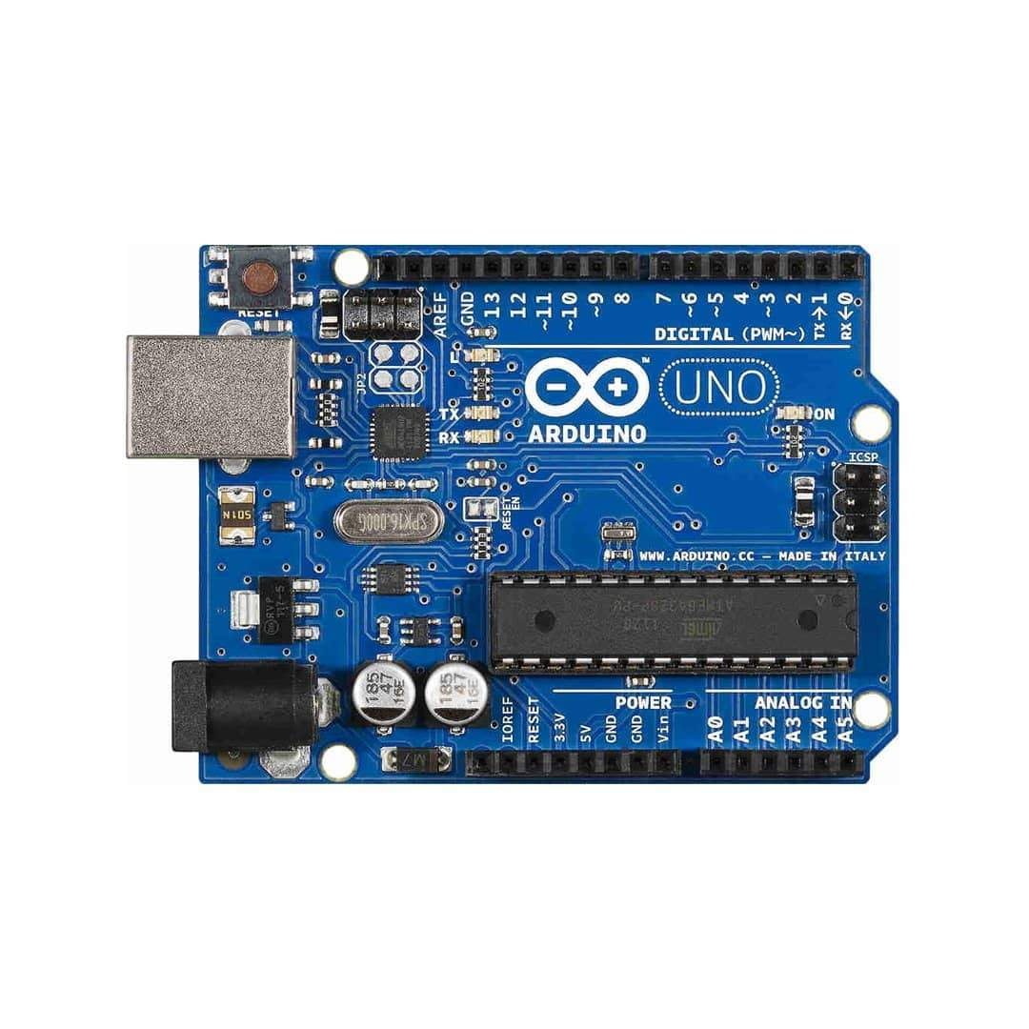
FIGURE 2.3: ARDUINO UNO

USE OF PROTEUS AND TINKERCAD
We used Proteus and Tinkercad as the core of our project design process. these tools help us to practice the digital model before building a physical model.
TINKERCAD: We are using this for 3D layout and basic circuit testing. It helps us visualize how the parts fit together.
PROTEUS: We use it to simulate the actual electrical behavior of our custom PCB and verify that our code won't fry the components.

CHAPTER 3: METHODOLOGY

SYSTEM BLOCK DIAGRAM
The system design of the line following robot is designed to facilitate high speed decision making and precise motor control. The block diagram explains the closed loop signal flow that traces the signal path from thr initial detection of sensor data to final mechanical movement.
FIGURE 3.1: SYSTEM BLOCK DIAGRAM
As shown in the diagram the system is organized into five parts that works as a continuous feedback loop:
IR sensor (CNY70): It picks up the differences between the black line and white surface. Then sends it as an analog signal to the robot’s brain.
Arduino Uno: It takes in data from the sensors and runs the control algorithm. Based on that info, it decides how fast to go and which way to turn.
L293D Motor Driver: The Arduino isn’t strong enough to power the motors directly. That’s where the L293D steps in. It takes the low-power signals from the Arduino and turns them into the higher voltage the motors need to actually move.
DC Motors: These do the physical work. When they get the voltage from the motor driver, they spin and make the robot move forward, backward, or turning as needed.
Power Source (9V Battery & 5V Regulator): The battery gives the whole system its power. The regulator makes sure the Arduino and sensors get a steady 5V, while the motors get the higher voltage they need.

HARDWARE DESIGN
This hardware setup brings together an ATmega328P microcontroller, some infrared sensing, and a beefy motor driver. The goal? Let the system navigate on its own.

ANALOG CIRCUIT DESIGN
The analog part has two main jobs: keeping the power steady and grabbing raw data from the surroundings.
SENSOR INTERFACING: Here, the system uses a CNY70 reflective optical sensor (Q1). The IR LED gets its current through a 220Ω resistor (R1). On the other side, the phototransistor sits in a common-emitter setup with a 10kΩ pull-up resistor (R3). Basically, they work together as a voltage divider the output signal changes depending on how much light the surface reflects, and that’s what the microcontroller reads.
POWER SUPPLY SYSTEM: Power-wise, the design uses two voltage levels. A 12V battery (B1) feeds the motor drivers with the high current they need. For the logic side stuff like the Arduino and sensors there IS a regulated 5V DC source (V1). This setup keeps the signals stable and stops annoying reset loops when the motors kick in.

MICROCONTROLLER PIN MAPPING
The brains of the operation are an Arduino Uno. It’s a solid pick because it can juggle several digital inputs and crank out PWM signals for motor control in real time. That makes it a great fit for this kind of project.
Component | Arduino Pin | Pin Function | Description
CNY70 Sensor | A0 | Analog Input | Detects Line/Surface
L293D (IN1) | D2 | Digital Output | Motor 1 Direction Control
L293D (IN2) | D3 | Digital Output | Motor 1 Direction Control
L293D (IN3) | D4 | Digital Output | Motor 2 Direction Control
L293D (IN4) | D5 | Digital Output | Motor 2 Direction Control

COMPLETE SCHEMATIC IN PROTEUS
We put schematic together in Proteus Design Suite. It shows how the Arduino connects to the L293D Push-Pull Four-Channel Driver (labeled U2) and the DC geared motors. Everything—logic and power—shares the same ground, so you don’t end up with floating signals or weird voltage issues.
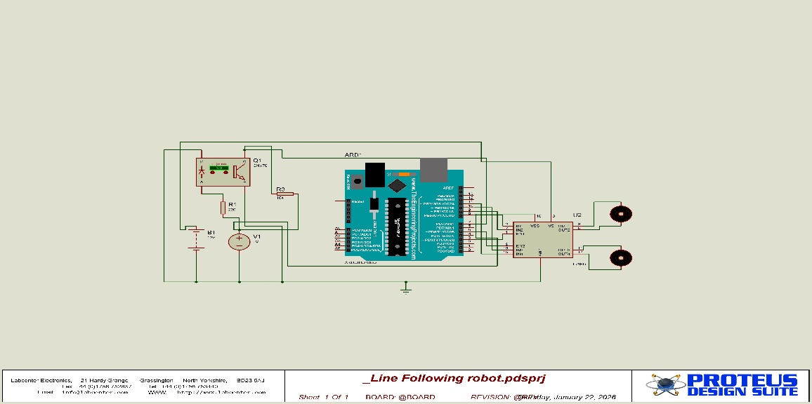
FIGURE 3.2.3: ANALOG CIRCUIT DESIGN

SIMULATION RESULTS IN PROTEUS
Running the simulation in Proteus, a few things stood out:
Logic works when the CNY70 sensor changes at Pin A0, the Arduino flips pins D2 through D5 just like it should.
Motors respond the L293D does its job, taking those low-current logic signals and cranking them up to drive the two DC motors in the schematic.
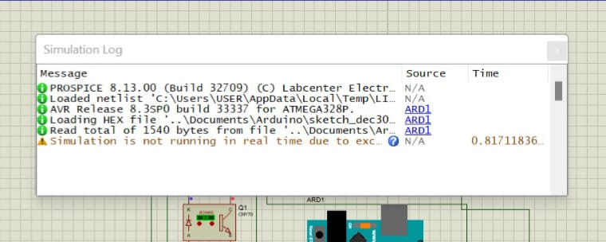
FIGURE 3.2.4: SIMULTION LOG

TINKERCAD 3D SIMULATION
We used Tinkercad to lay out the chassis in 3D. With the 9V battery and breadboard in place, I could make sure the CNY70 sensor sits right where it needs to out 1 to 5 millimeters above the track. That’s the sweet spot for picking up the black line reliably.
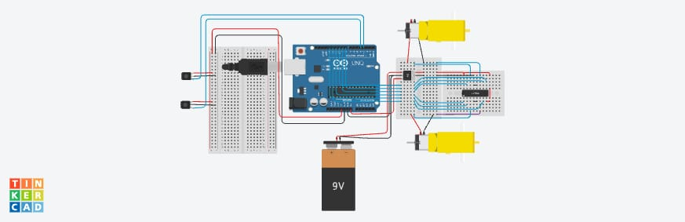
FIGURE 3.2.5: TINKERCAD 3D SIMULATION

PCB DESIGN
Here’s where the Proteus schematic turns into a real, physical PCB, with a focus on keeping signals clean and power steady.

COMPONENT FOOTPRINT SELECTION
Before routing, We picked out the right footprints for every part on the schematic:
- DIL-16 for the L293D motor driver—makes it easy to swap out and helps with heat.
- DIL-28 for the Arduino Uno interface. This way, you can mount the PCB as a shield or hook it up with ribbon cables.
- 2-pin terminal blocks for both the 12V battery input and the DC motor outputs. These keep those high-current connections solid and safe.

PCB LAYOUT AND ROUTING STRATEGY
The layout’s all about cutting down on electromagnetic interference from the motors.
- Trace width matters. I set power traces (V_S and Ground) between 30 and 40 mils, so they can handle the current spikes from the DC motors and don’t overheat. Logic signal traces (A0, D2–D5) are thinner, at 12–15 mils.
- For grounding, there’s a copper pour ground plane on the bottom layer. It reduces noise and gives a low-impedance path back for the analog sensor signal from the CNY70.
- Component placement isn’t random. The L293D sits at the center, keeping motor wires short. The CNY70 header goes right at the board’s front edge for the best line detection.
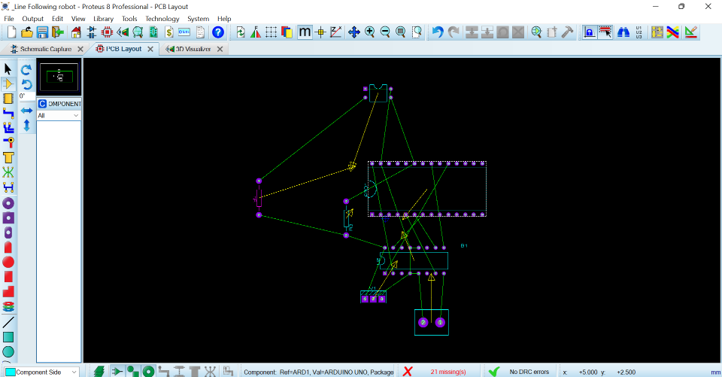
FIGURE 3.3.2: PCB LAYOUT
    - 3D VISUALIZATION
We used the Proteus ARES 3D visualizer to check for any clearance problems.
In the 3D view, we made sure the electrolytic capacitors wouldn’t get in the way of the robot chassis or block the sensor’s view.
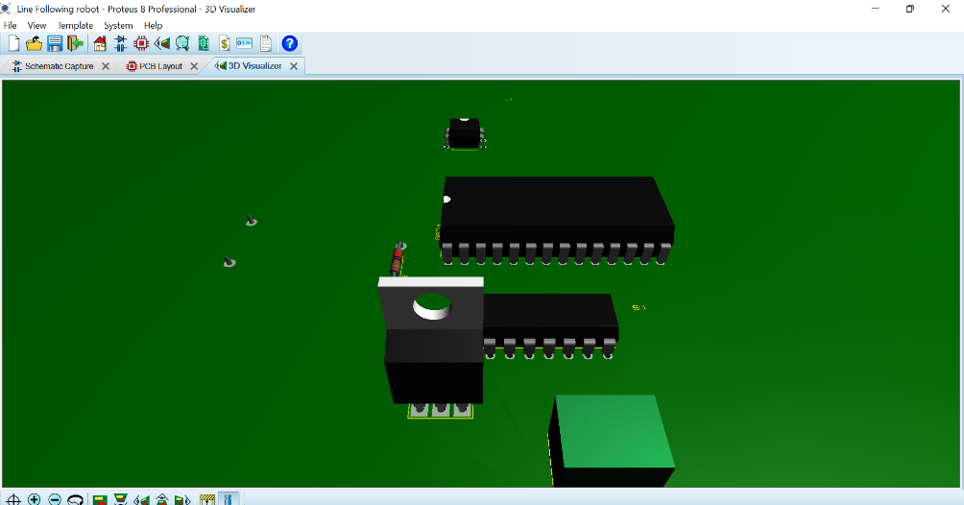

SOFTWARE DEVELOPMENT
The software architecture lets the system grab fast data from the CNY70 optical sensor and turn that info into sharp motor movements using the L293D H-Bridge.

CONTROL LOGIC AND FLOWCHART
Here is how it works: The system runs on closed-loop feedback. The microcontroller keeps checking the analog input from pin A0, comparing it with a set threshold you calibrate ahead of time. That is how it knows if the robot’s rolling over the track (which reflects less light) or the background (more reflection).
First, it sets things up. It picks a baud rate for serial debugging and sets pins D2 through D5 as outputs. Then it reads the voltage from the CNY70. Next, it uses a simple “if-else” check—if the reading is under the threshold, the robot’s on track. If not, it’s off track. Depending on what it finds, it updates the L293D’s input pins and tweaks the steering.
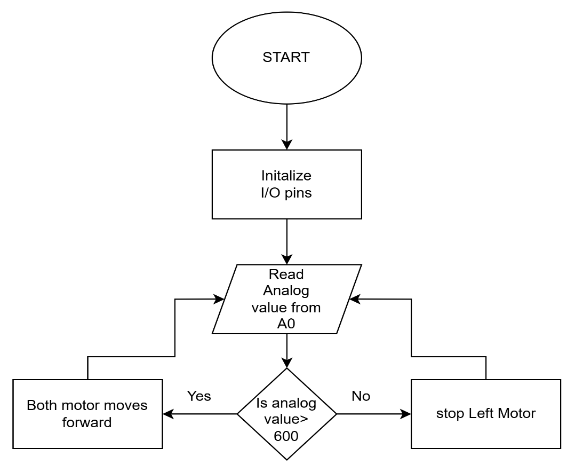

PROGRAMMING IMPLEMENTATION (CODE SNIPPET)
Below is a C++ code sample for the ATmega328P. This version has a calibration variable, so you can adjust it for different lighting.
// ICT 215 - Line Follower Control Code
const int SENSOR_PIN = A0;
const int THRESHOLD = 600; // Calibrated value for black line
// Motor Pin Mapping (Section 3.2.2)
const int L_MOTOR_F = 2;
const int L_MOTOR_B = 3;
const int R_MOTOR_F = 4;
const int R_MOTOR_B = 5;
void setup() {
pinMode(SENSOR_PIN, INPUT);
for(int i=2; i<=5; i++) pinMode(i, OUTPUT);
}
void loop() {
int val = analogRead(SENSOR_PIN);
if (val > THRESHOLD) {
// Action: Move Forward (Both motors ON)
digitalWrite(L_MOTOR_F, HIGH); digitalWrite(R_MOTOR_F, HIGH);
digitalWrite(L_MOTOR_B, LOW); digitalWrite(R_MOTOR_B, LOW);
} else {
// Action: Search/Pivot (Left motor OFF, Right motor ON)
digitalWrite(L_MOTOR_F, LOW); digitalWrite(R_MOTOR_F, HIGH);
digitalWrite(L_MOTOR_B, LOW); digitalWrite(R_MOTOR_B, LOW);
}
}

CHAPTER 4: RESULTS AND DISCUSSION

4.1 SIMULATION RESULTS
Simulation was performed using Proteus Design Suite and Tinkercad to validate the system before physical implementation. These simulations allowed verification of circuit logic, sensor response, and motor control behavior without risking hardware damage.

4.1.1 PROTEUS SIMULATION RESULTS
Proteus simulation confirmed the proper functionality of the analog sensing circuit, microcontroller processing, and motor driver output. When the reflective optical sensor detected a white surface, a higher voltage signal was produced and read by the Arduino Uno through analog pin A0. When the sensor detected the black line, the reflected infrared light was reduced, resulting in a lower voltage signal.
The Arduino microcontroller successfully interpreted these signals and generated corresponding digital outputs through pins D2–D5. These outputs controlled the L293D motor driver, which in turn controlled the DC motors.
Key observations from Proteus simulation include:
• Proper sensor signal variation between black and white surfaces
• Correct digital output switching from Arduino pins
• Successful activation and direction control of DC motors
• No signal instability or unexpected circuit behavior
4.1.2 TINKERCAD SIMULATION RESULTS
Tinkercad was used to visualize the physical layout and verify system integration. The simulation allowed testing of:
• Sensor placement and alignment
• Battery positioning and wiring
• Breadboard connections
• Overall structural layout of components
The simulation confirmed that all components were properly connected and that the system logic worked correctly in a virtual hardware environment.
The results demonstrated that the robot would be able to detect the line and respond appropriately in real-world implementation.

4.2 DISCUSSION OF FINDINGS (COMPARISON WITH LITERATURE)
The results obtained from this project align with previous research on line following robots discussed in Chapter 2.
Similar to standard microcontroller-based line followers, this robot used an Arduino Uno to process sensor input and control motors efficiently. The system demonstrated accurate line detection and autonomous navigation, confirming the effectiveness of combining analog sensing with digital control.
Compared with purely analog line following robots, this system provided greater flexibility and accuracy due to programmable control logic.
The use of PCB design also improved signal stability and system durability, which is consistent with modern robotics design practices.
The project successfully demonstrated the practical implementation of autonomous robotic navigation using embedded systems.

4.3 PROBLEMS ENCOUNTERED AND SOLUTIONS
During the development and testing process, several challenges were encountered.
Problem 1: Incorrect Sensor Readings
Cause: Improper sensor height and ambient light interference.
Solution: Sensor height was adjusted to 2–5 mm above the surface and threshold value was recalibrated.
Problem 2: Motor Not Responding Properly
Cause: Incorrect wiring between Arduino and motor driver.
Solution: Connections were checked and corrected according to the schematic diagram.

Problem 3: Power Instability
Cause: Voltage fluctuations when motors started.
Problem 4: Incorrect Motor Direction
Cause: Incorrect motor polarity.
Solution: Motor wires were reversed to correct direction.

CHAPTER 5: CONCLUSION AND RECOMMENDATIONS

5.1 SUMMARY OF FINDINGS
This project successfully achieved the design, simulation, and implementation of a line following robot using analog sensing and microcontroller-based control.
The system was developed using the following components:
• CNY70 infrared sensor for line detection
• Arduino Uno microcontroller for control processing
• L293D motor driver for motor control
• DC motors for movement
• Custom PCB for system integration
Simulations performed in Proteus and Tinkercad confirmed the correctness of the circuit design and control logic. The physical prototype also demonstrated reliable and accurate line following capability.
The use of PCB design significantly improved system stability and performance.

5.2 CONCLUSION
The line following robot was successfully designed, simulated, and implemented. The robot was able to detect and follow a black line on a white surface accurately and autonomously.
The integration of analog circuitry, embedded programming, simulation tools, and PCB design resulted in a complete and functional robotic system.
This project demonstrated the practical application of embedded systems, analog electronics, and robotic control principles.
The project objectives were fully achieved.

5.3 RECOMMENDATIONS (INDUSTRY AND FUTURE STUDENTS)
Based on the results obtained, the following recommendations are suggested:
For Industry:
• Line following robots can be used in warehouses for automated transportation
• Can improve efficiency and reduce human labor
• Can be integrated into automated guided vehicle (AGV) systems
For Future Students:
• Use multiple sensors for improved accuracy
• Implement PID control for smoother motion
• Use rechargeable battery for longer operation
• Improve chassis design for better stability

5.4 CONTRIBUTION TO KNOWLEDGE
This project contributes to knowledge in the field of robotics and embedded systems by demonstrating the complete design process of a line following robot from simulation to hardware implementation.
It also provides a practical reference for students learning:
• Embedded system design
• Analog sensor interfacing
• PCB design and routing
• Robotics control systems
The project also provides open-source documentation through GitHub.

5.5 LIMITATIONS
The following limitations were identified:
• Only one sensor was used, limiting accuracy on complex paths
• No PID control was implemented
• Robot speed was limited
• Battery life was limited
• Mechanical design was basic
These limitations can be improved in future versions.

5.6 SUGGESTIONS FOR FUTURE WORK
Future improvements may include:
• Use of multiple sensors for better line detection
• Implementation of PID control algorithm
• Use of rechargeable lithium battery
• Addition of obstacle detection sensors
• Wireless control and monitoring
• Improved mechanical chassis design
• Integration with IoT systems

